ACF Presenter Name | Bio | Photo
Sheri Harmon | Sheri Harmon has 20 years of experience with Administration for Children and Families mandatory and discretionary grants, working with a variety of recipients. As a Grants Management Specialist with the Office of Grants Management, Sheri has supported specialized teams, such as Audit Resolution, Real Property, and Disaster Recovery. | 
Melissa Adams | Melissa Adams, Grants Management Specialist holds her master's degree in Nonprofit Management and Leadership. Prior to joining the Administration for Children and Families, Melissa provided training and technical assistance to Head Start recipients under a federal contract with the University of Massachusetts. She has extensive experience in the nonprofit field, having managed multiple programs funded through federal and state grant awards including Head Start and Child Care. Melissa resides in Massachusetts and works with the Strategic Operations and Innovation Division of the Office of Grants Management. | 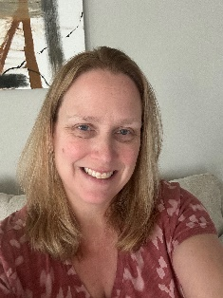
Bridget Shea Westfall | Bridget Shea Westfall is a Supervisory Grants Management Officer in the Division of Innovation and Improvement Assistance in Washington, DC where she leads a team of grants management specialists managing a portfolio on research, evaluation, technical assistance and innovative social service delivery and design. Her team of grants management specialists provide fiscal and administrative oversight, training, and technical assistance to competitive grant programs in the Children’s Bureau, Office of Child Care, Office of Community Services, Office of Child Support Services, Office of Planning, Research and Evaluation and Office of Refugee Resettlement. Bridget is an advanced-track educator for the National Grants Management Association on diversity, equity, inclusion and belonging in grants management. Ms. Shea Westfall is a graduate of the University of Missouri and the Brown School of Social Work at Washington University in St. Louis. | 